**Assignment 1, Cloud Computing**

**Kerimbay Kairuddin**

**Exercise 1: Understanding Cloud Computing Models**

IaaS (Infrastructure as a Service), PaaS (Platform as a Service), and SaaS (Software as a Service) are three fundamental models of cloud computing, each offering different levels of abstraction and control to users.  
  
**1) What are the main differences between IaaS, PaaS, and SaaS?**

|  |  |  |  |
| --- | --- | --- | --- |
| **Feature** | **IaaS** | **PaaS** | **SaaS** |
| Abstraction Level | Lowest | Medium | Highest |
| Control | Highest | Medium | Lowest |
| Components | Hardware (servers, storage, networking) | Operating system, programming languages, database | Entire application |
| User Responsibilities | Managing operating systems, applications, and security | Managing applications and data | Accessing and using the application |
| Examples | AWS, Azure, GCP | Heroku, Google App Engine, AWS Elastic Beanstalk | Salesforce, Microsoft 365, Google Workspace |
| Ideal For | Businesses with significant IT expertise and flexibility requirements | Developers building web applications or mobile apps | Businesses that need ready-to-use applications |

**2) Which GCP services fall under each of these models?**

**IaaS:** Compute Engine: virtual machines, Cloud Run: serverless computing**,** Cloud Storage: object storage, Persistent Disk: block storage, Cloud SQL: managed database**,**  Cloud Load Balancing, Cloud DNS.

**PaaS:** App Engine: fully managed platform for web applications, Cloud Functions: serverless functions**,** Cloud Dataflow: data processing pipelines, AI Platform: machine learning platform**,** Cloud Endpoints: API management

**SaaS:**  Google Workspace (Gmail, Docs, Sheets, etc.) collaboration with Google Chat, Google Meet and business applications: Google Cloud Search, Google Analytics.

3) **Provide a real-world example where each cloud service model might be the most appropriate choice**

**IaaS**: A large e-commerce company needs to scale their infrastructure rapidly during peak shopping seasons. They choose IaaS to have full control over their resources and can easily provision additional servers, storage, and networking components as needed.

**PaaS**: A startup is developing a mobile app and wants to focus on building the application itself without worrying about managing underlying infrastructure. They use PaaS to deploy their app on a scalable platform, handling tasks like server management, operating system updates, and database administration.

**SaaS**: A small business needs a customer relationship management (CRM) system but doesn't have the IT resources to manage it in-house. They opt for a SaaS CRM solution, which is hosted by the provider and accessible via the internet, allowing them to focus on their core business.

**Exercise 2: Exploring Google Cloud Platform's Core Service**

**1) What is the primary use case of Compute Engine?**

Compute Engine's primary use case is to provide scalable and reliable virtual machines (VMs) for running various applications and workloads on Google Cloud Platform (GCP).

**2) How does Google Kubernetes Engine (GKE) simplify the management of containerized applications?**

GKE simplifies container management by handling infrastructure, scaling, and integration, while ensuring security, supporting blue-green deployments, and working with CI/CD tools.

**3) What advantages does Cloud Storage offer for data management**?

**Scalability**: It can easily scale to accommodate growing data needs without requiring significant upfront investment.

**Durability**: Data is stored redundantly across multiple data centers, ensuring high availability and durability.

**Accessibility**: Data can be accessed from anywhere in the world with an internet connection.

**Cost-effective**: Cloud Storage can be more cost-effective than traditional on-premises storage solutions, especially for large datasets.

**Integration**: It integrates seamlessly with other Google Cloud Platform services, making it easy to manage and analyze data.

**Security**: Cloud Storage provides robust security features, including encryption and access controls.

**4) Why would a business choose Big Query for their data analysis needs?**

It can handle massive datasets with billions of rows and petabytes of data. There's no need to manage infrastructure, allowing businesses to focus on analysis. Big Query is designed for fast query performance, even on large datasets. It integrates seamlessly with other GCP services, making it easy to work with data from different sources. Pricing is based on the amount of data processed, making it cost-effective for most workloads. Big Query uses a standard SQL dialect, making it easy for analysts to use.

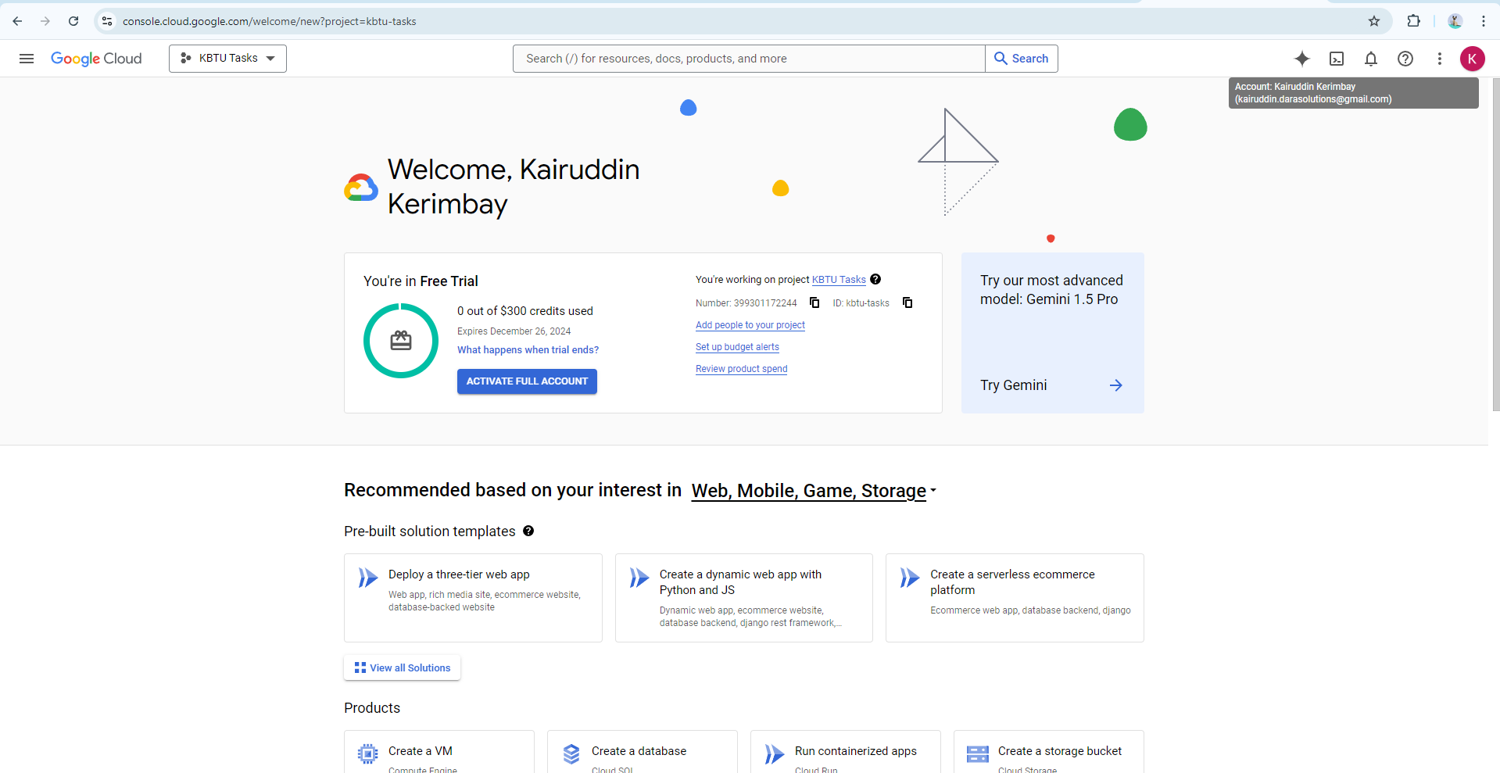

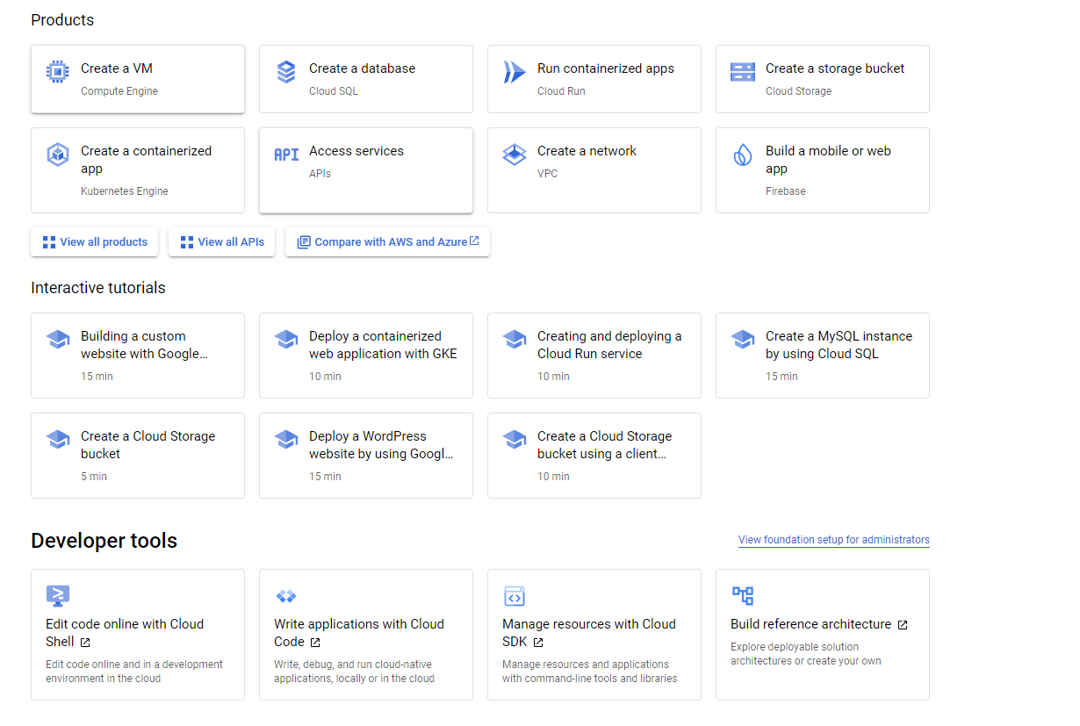

### Exercise 3: Creating and Managing Virtual Machines with Compute Engine

### In the Google Cloud Console, navigate to Compute Engine and create a new VM instance.

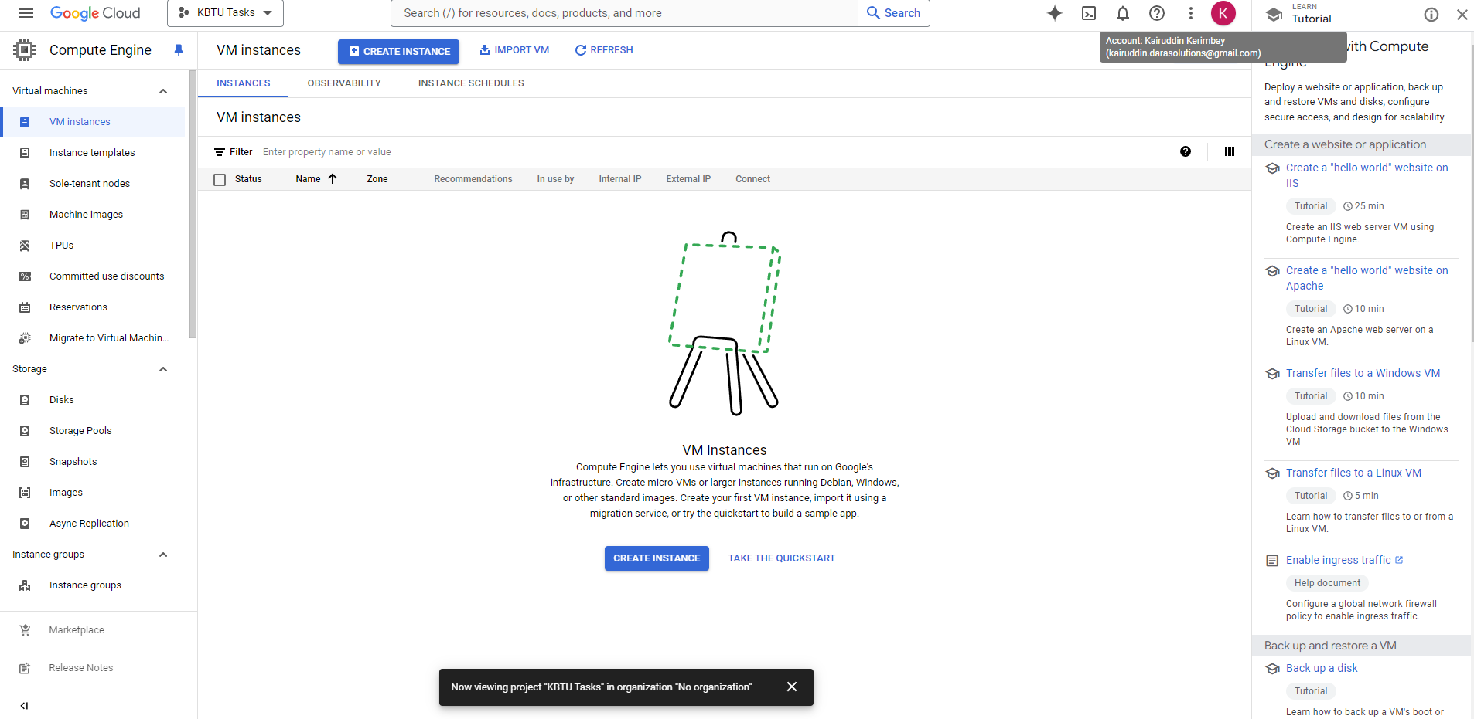

Configure the VM with specific parameters, such as the machine type, region, and operating system

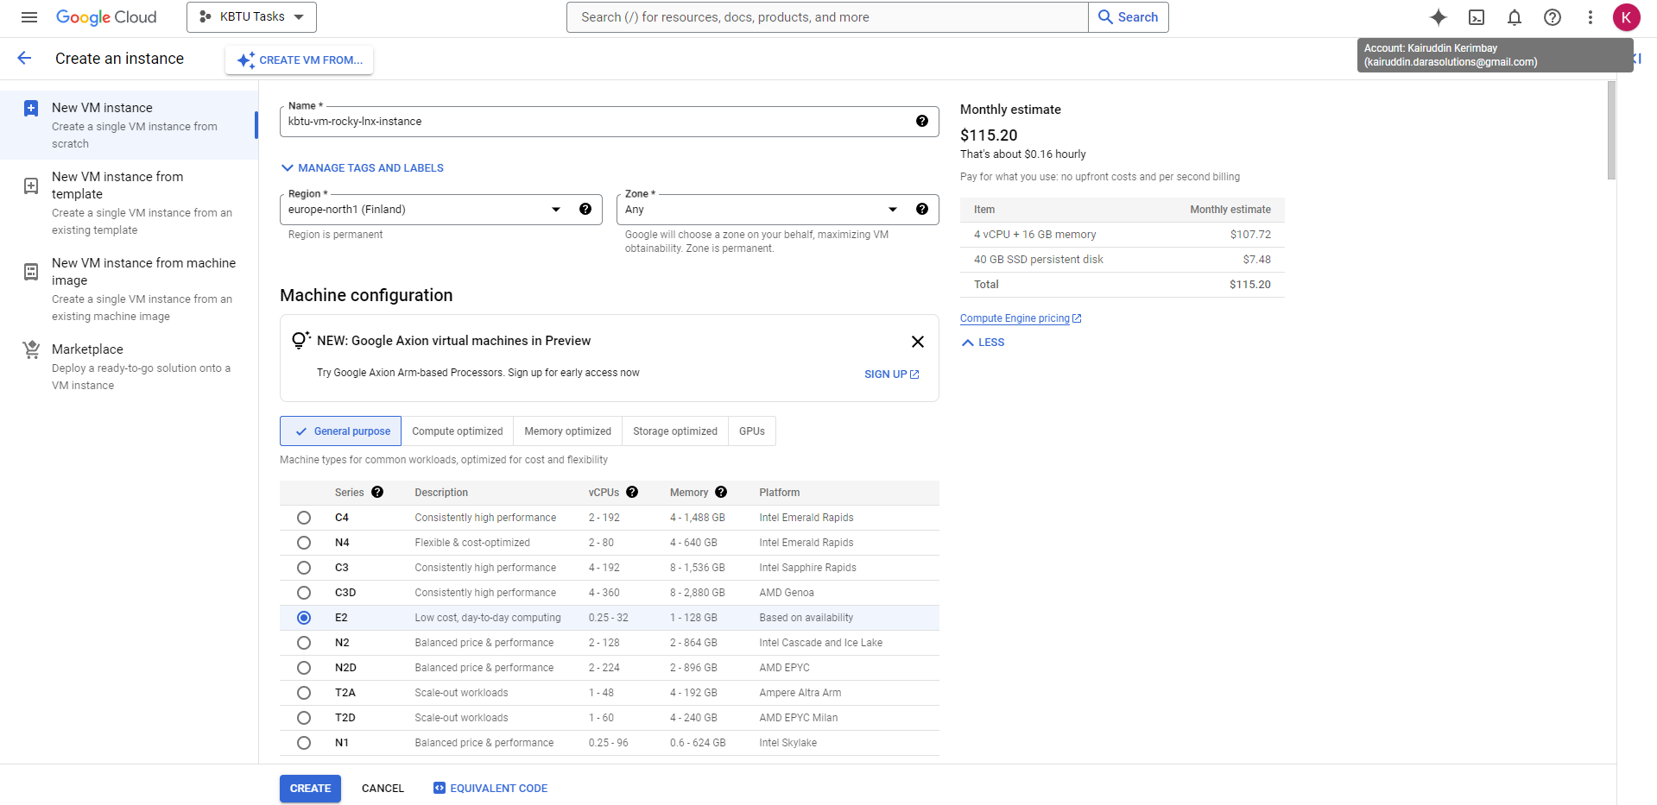

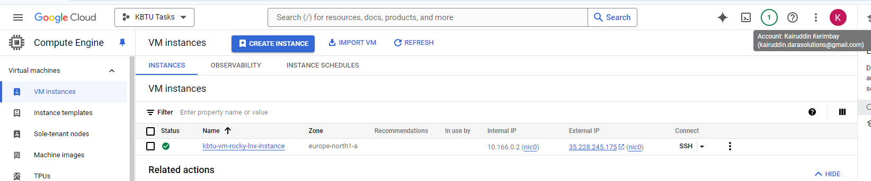

Connect to the VM using SSH and install a basic web server (e.g., Apache or Nginx)

**Firstly, upgraded system**:

sudo dnf update -y

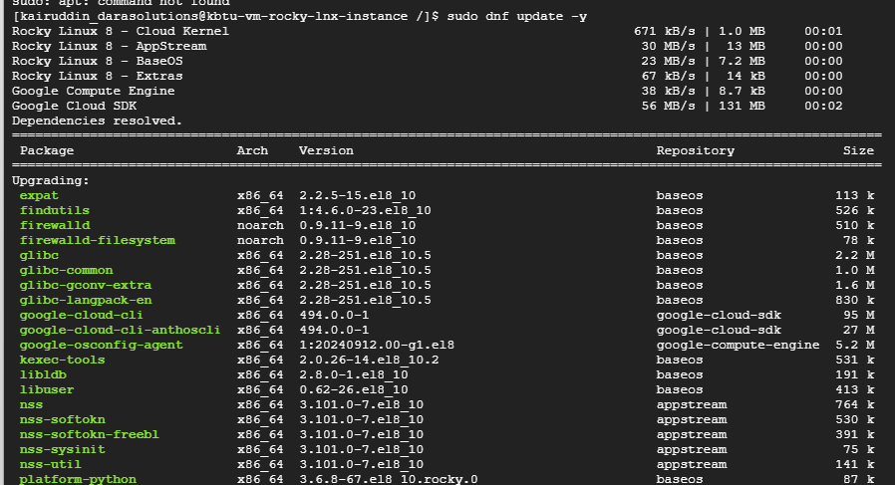

**Then installed nginx**

sudo dnf install nginx -y

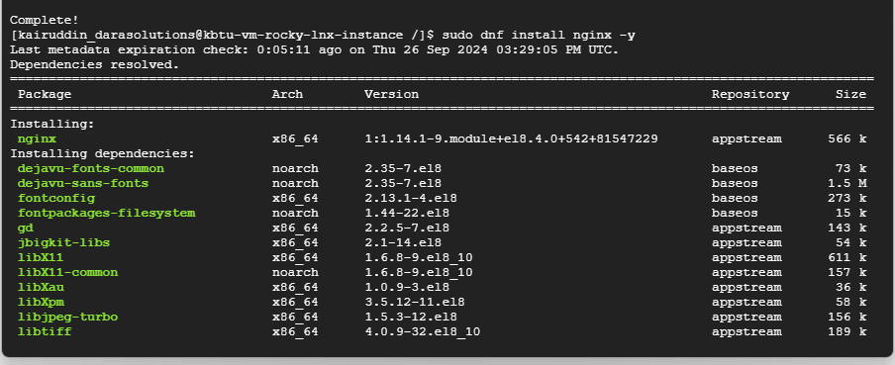



**Here started nginx**

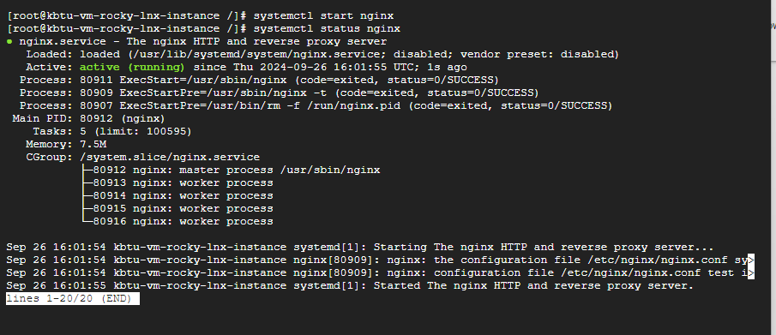

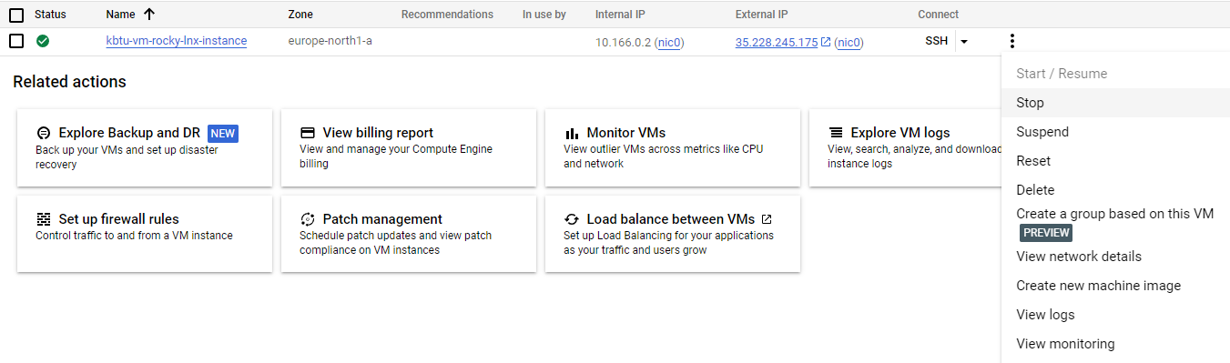

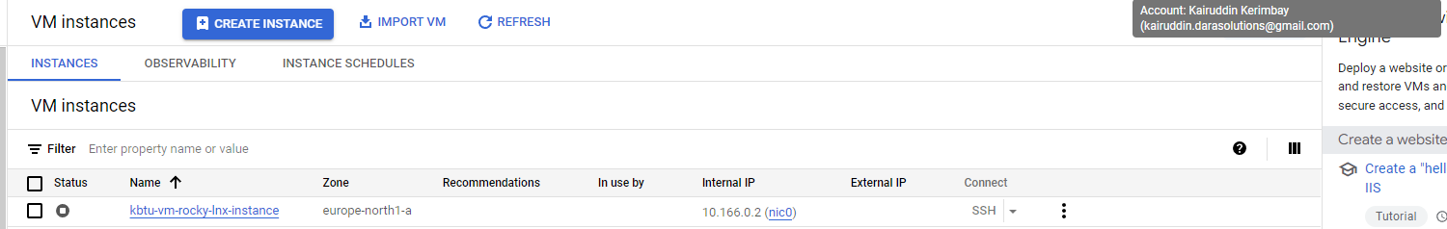

**Exercise 4: Deploying a Containerized Application on Google Kubernetes Engine (GKE)**

Commands used:

**gcloud auth configure-docker**

**docker tag my-spring-app gcr.io/kbtu-tasks/my-spring-app**

**docker push gcr.io/kbtu-tasks/my-spring-app**

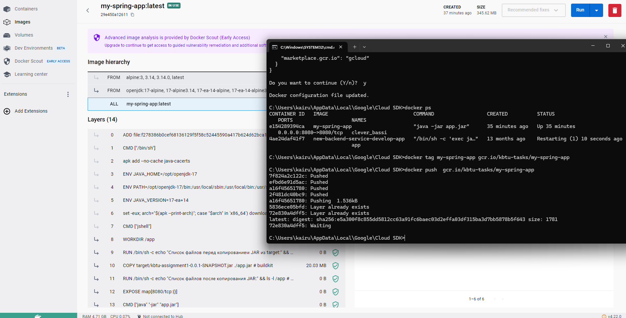

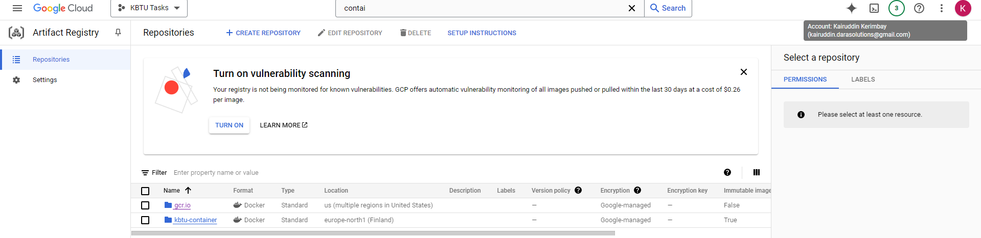

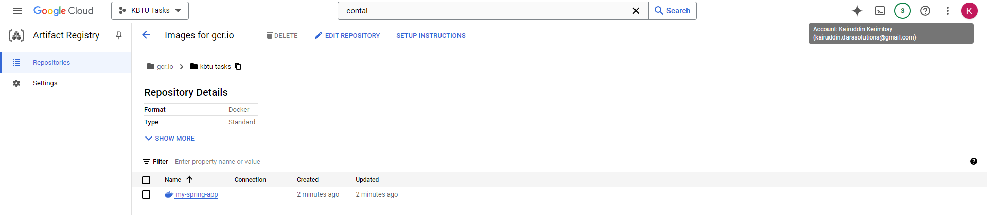

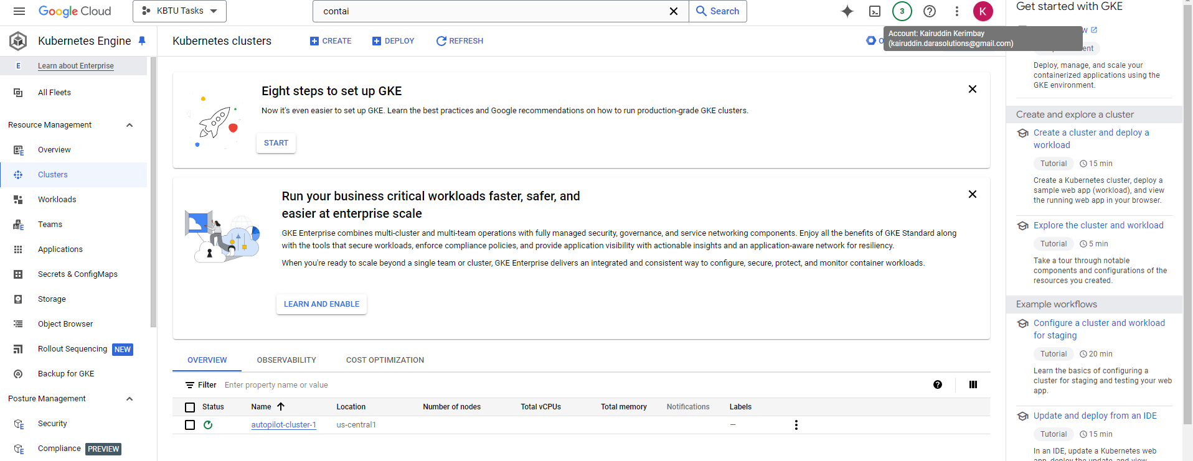

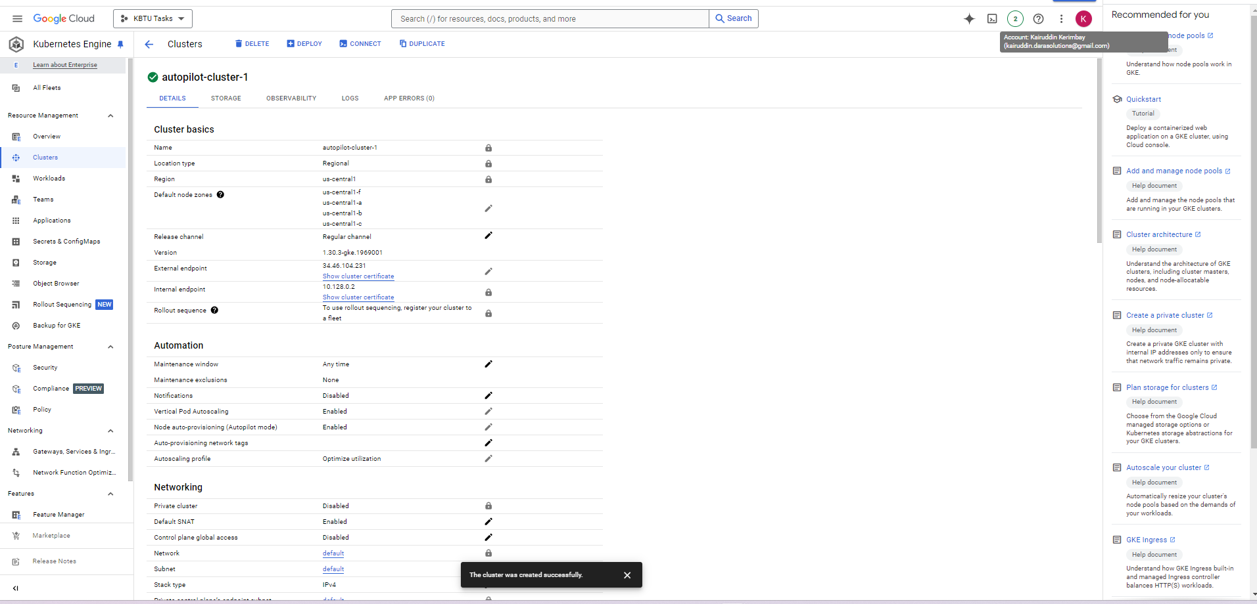

Create a GKE cluster in Google Cloud Console.

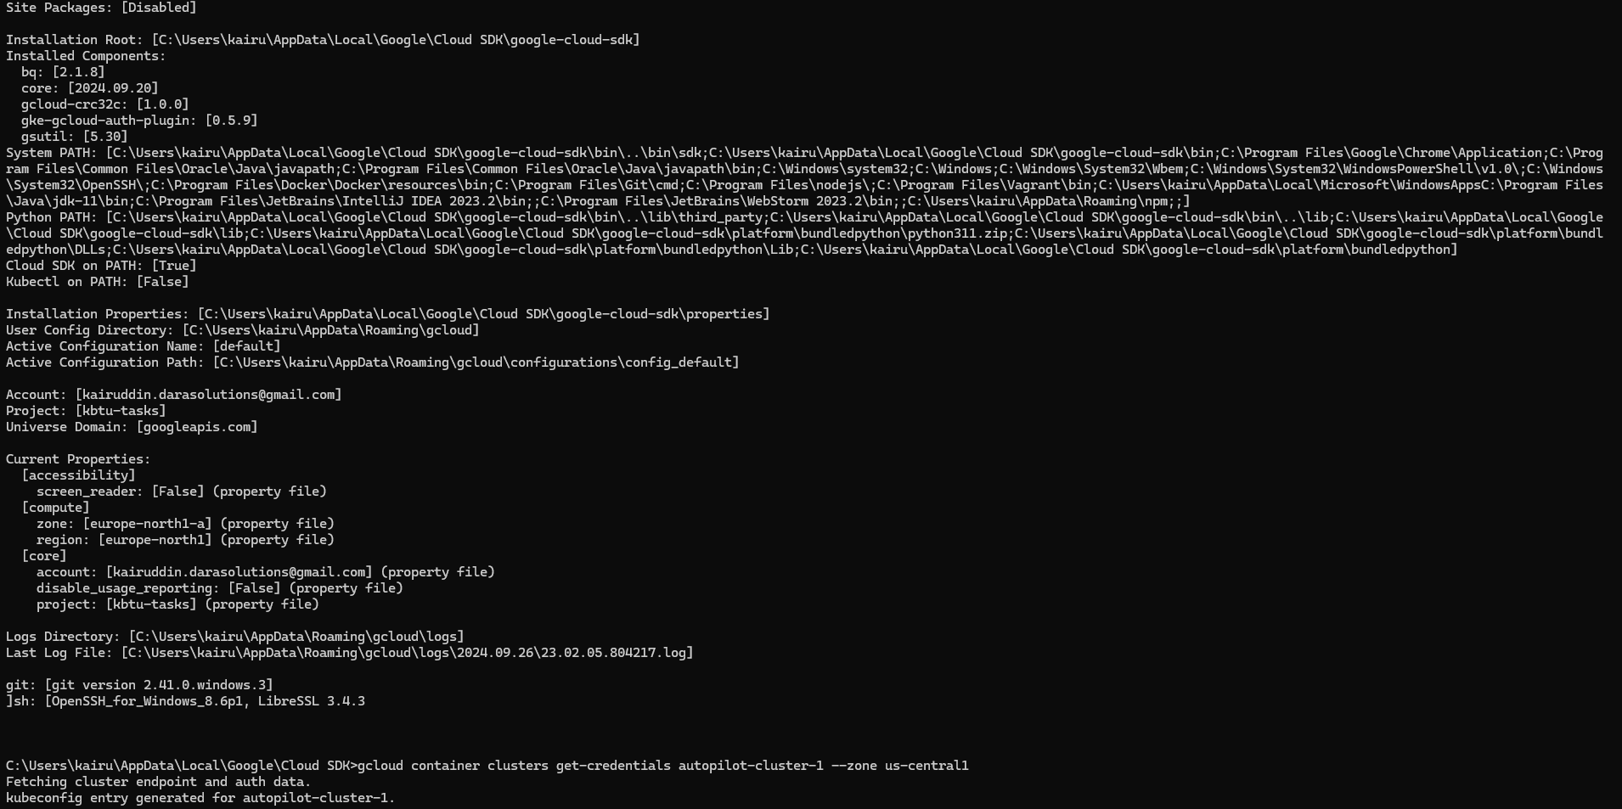

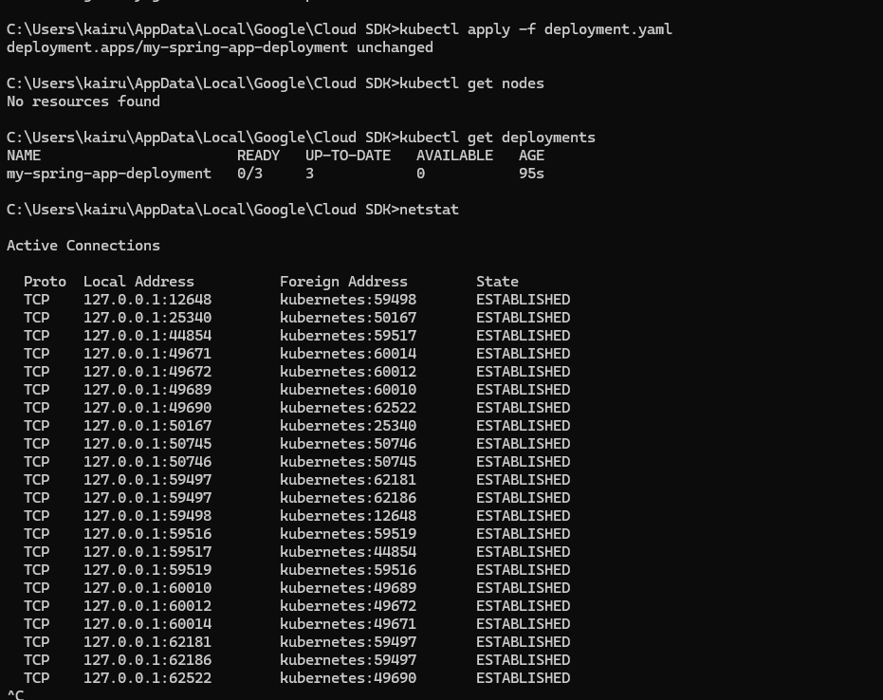

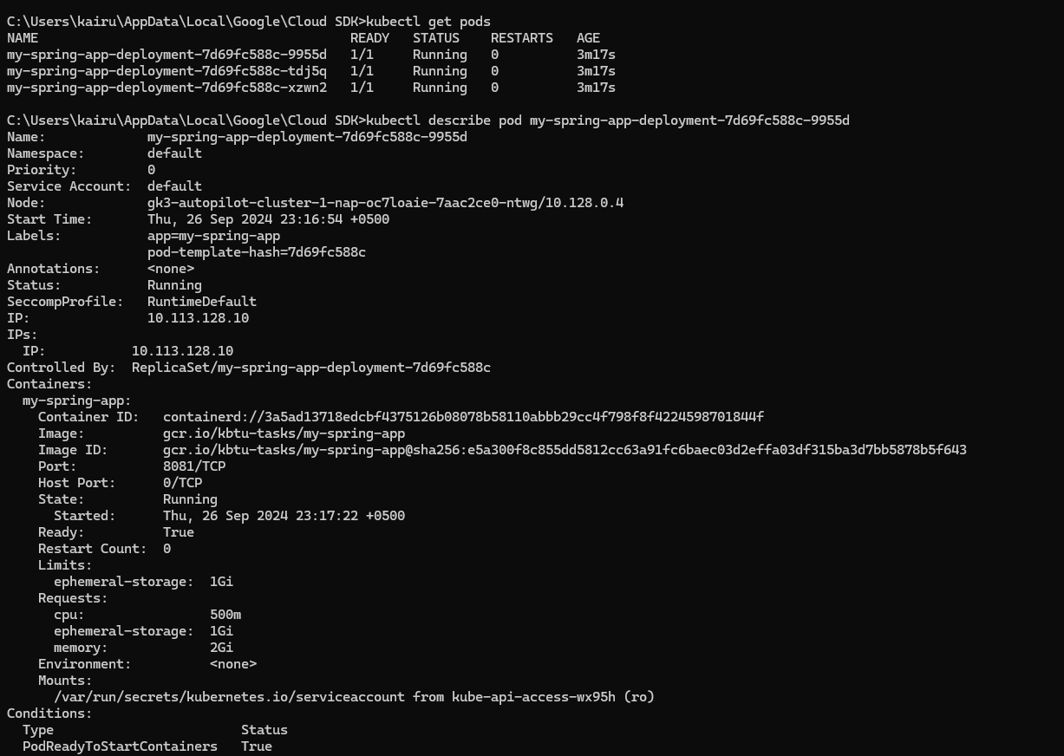

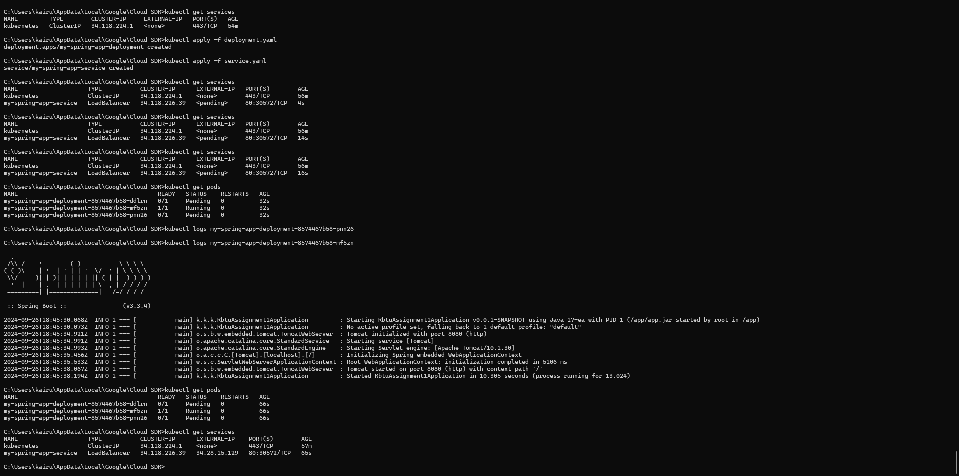

How did you verify that your application was successfully deployed and accessible?

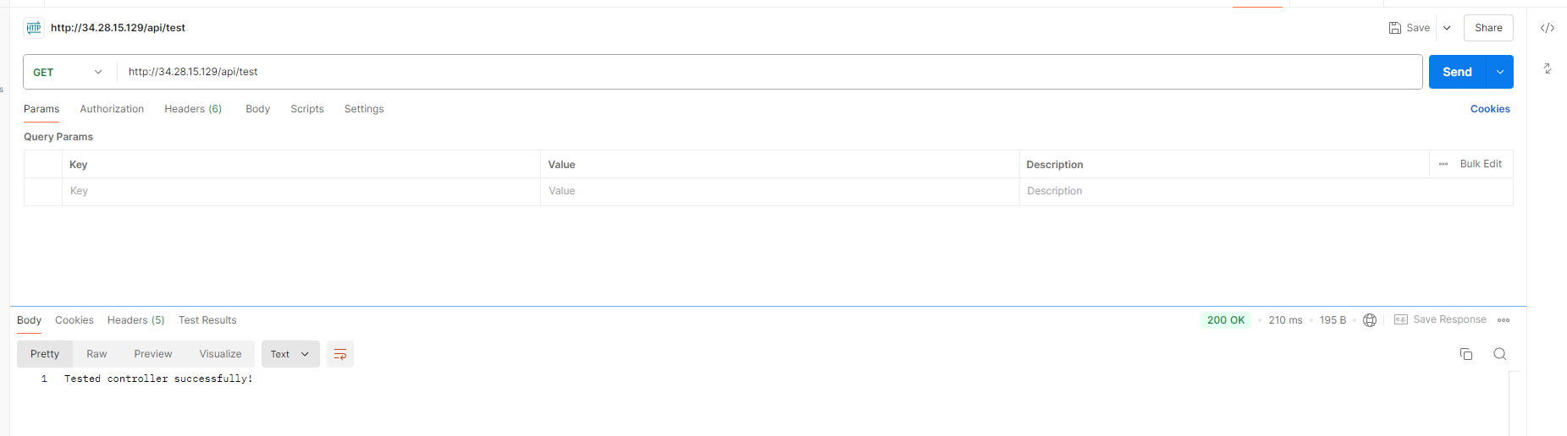

CONGRATS 🎉🎉🎉

**Exercise 5: Storing and Accessing Data in Google Cloud Storage**

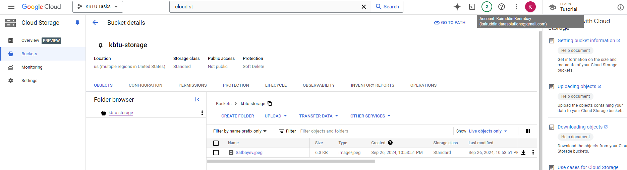

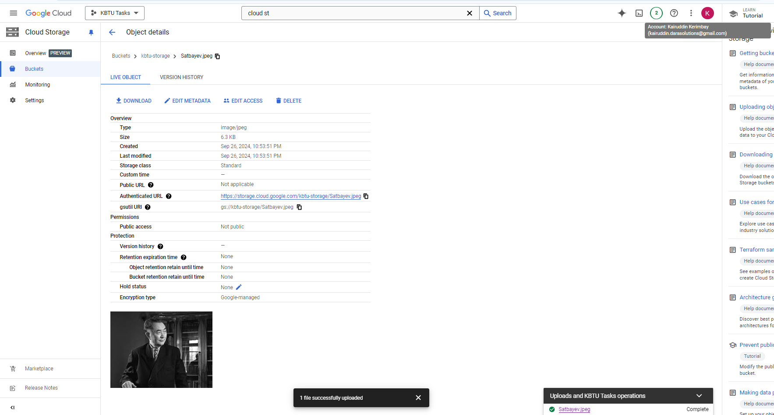

**Exercise 6: Analyzing Data with BigQuery**

CREATE SCHEMA my_dataset

OPTIONS

(

  location = 'US'

);

CREATE OR REPLACE TABLE my_dataset.orders (

  order_id INT64,

  customer_id INT64,

  order_date DATE,

  order_amount FLOAT64,

  status STRING

);

INSERT INTO my_dataset.orders (order_id, customer_id, order_date, order_amount, status)

VALUES

  (1, 101, '2023-09-01', 150.50, 'completed'),

  (2, 102, '2023-09-02', 200.00, 'pending'),

  (3, 101, '2023-09-03', 99.99, 'completed'),

  (4, 103, '2023-09-04', 350.75, 'completed'),

  (5, 104, '2023-09-05', 450.00, 'cancelled'),

  (6, 105, '2023-09-06', 300.20, 'pending');

SELECT * from my_dataset.orders;

SELECT * FROM my_dataset.orders WHERE status = 'completed';

SELECT status, COUNT(*) AS order_count FROM my_dataset.orders

GROUP BY status

ORDER BY order_count DESC;

